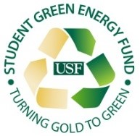
USF Sarasota-Manatee Student Green Energy Fund Committee
Date: Wednesday, July 17, 2024
Time: 1:00pm - 2:00pm
Venue: Virtual via Teams
Agenda

- Call to Order
- Approval of the Minutes from July 10th, 2024
- Approval of Agenda
- Business from the Previous Meeting
  - Discussion and adoption of Project Evaluation Rubric
- New Business
  - Project Proposal Presentation by Facilities Planning and Management Team
  - Discussion of additional opportunities for the SGEF to be of use to students on campus
- Member Comments/Announcements
- Next Meeting: TBD
- Adjournment

